**SYSTEM ANALYSIS & DESIGN REPORT**

**FOR**

**Development of I&T Project**

**Management Information System (INTPMIS)**

**OF**

**Electrical and Mechanical Services Department**

Version: 1.0

**September 2020**

© The Government of the Hong Kong Special Administrative Region

The contents of this document remain the property of and may not be reproduced in whole or in part without the express permission of the Government of the HKSAR

| **Distribution** | |
| --- | --- |
| Copy No. | Holder |
| 1 |  |
| 2 | Master Concept (Hong Kong) Limited |

| Prepared By:  Derek Chan  [Programme Manager, MCHK] | Endorsed By:    [ ] |
| --- | --- |
| Date: 21/09/2020 | Date: |

| **Amendment History** | | | | | |
| --- | --- | --- | --- | --- | --- |
| Change Number | Revision Description | Pages Affected on Respective Version | Revision / Version Number | Date | Approval Reference |
|  |  |  |  |  |  |
|  |  |  |  |  |  |
|  |  |  |  |  |  |

*Table of Contents*

***Management Summary 4***

**Approval Sought 4**

**System Objectives 4**

**Background 4**

**Proposed System 5**

***Resource Implications 5***

***Implementation Plan 7***

***Current Environment Description 8***

**Current System Description 8**

**Current System Overview 8**

**Business Process Model 9**

**Current Problems and Issues 12**

***Requirements Specification 12***

**User Requirements 12**

Proposed System Overview 12

**Future Business Process 14**

**UI & UX Design 15**

Login page 15

Project Management- Create 15

Project Management- Edit 19

Project Management- View 22

Wish Management- Edit 22

Wish Management- View 25

Solution Management- Edit 25

Solution Management- View 27

Report Management- View 27

Log Management- View 32

**Functional Requirements 32**

List of Functional Requirements: 32

REQ-SYS-001 - Login 33

REQ-SYS-002 - Project List 33

REQ-SYS-003 - Create a Project 34

REQ-SYS-004 - View and Edit a Project 34

REQ-SYS-005 - Wish List 35

REQ-SYS-006 - View or Edit a Wish 36

REQ-SYS-007 - Solution List 36

REQ-SYS-008 - View and Edit a Solution 37

REQ-SYS-009 - Report List 37

REQ-SYS-010 - View Report 38

REQ-SYS-011 - Log List 38

REQ-SYS-012 - View Log List 39

REQ-SYS-013 - Upload Files 39

**Non-functional Requirements 40**

List of Functional Requirements 40

REQ-SR-001 Response Time 41

REQ-SR-002 Service Time 41

REQ-SR-003 Export 41

REQ-SR-004 Scalability 42

REQ-SR-005 System Performance 42

REQ-UR-001 User Interface Requirement 42

REQ-SCR-001 Function Access Rights 43

REQ-SCR-002 Access to Data 43

REQ-SCR-003 System Backup 44

**Technical Requirements 44**

List of Technical Requirements: 44

TR-SBR-001 Server House Keeping 44

TR-SBR-002 Backup, Recovery and System Archive 45

TR-DRR-001 System Disaster Recovery 45

***System Specification 46***

***Architecture Design 47***

***Selected Technical System Option 47***

***Hardware & Software Procurement 48***

**Hardware Procurement 48**

**Software Procurement 48**

***Programme Flow with Pseud-code Based, Software Module and Wireframe Mock-up 49***

***Management Summary***

*Approval Sought*

Approval is sought to endorse the System Analysis and Design (SA&D) report and to proceed to the Stage of System Implementation and Integration of the project. This report is compiled as a result of the SA&D study of the I&T Project Management Information System (INTPMIS) for the Electrical and Mechanical Services Department (“EMSD”) of the Government of the Hong Kong Special Administrative Region (“HKSARG” or “the Government).

*System Objectives*

The main objectives of future system are:

* to improve project management & control
* to make more effective use of experienced and inexperienced development staff
* to develop better quality systems
* to make projects resilient to the loss of staff
* to enable projects to be supported by computer-based tools such as computer-aided software engineering systems
* to establish a framework for good communications between participants in a project

*Background*

The INTPMIS is a relational database to store information of all I&T projects and provide analysis in the form of reports, tables and charts for decision making. The system aims to provide a reliable and accurate database to store relevant information in order keep track on the latest I&T development of the department.

The INTPMIS (relational database) consists of multiple flat tables and each flat table contains at least 40 numbers of data fields.

The INTPMIS shall also import part of the data from the existing central management system of E&M InnoPortal.

*Proposed System*

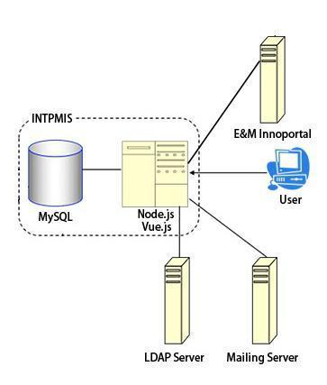

The proposed INTPMIS is a web-based application which is built using Node.js, Vue.js, and MySQL. INTPMIS is designed for bridging the information and collaboration between different users. It interfaces with the online platform E&M InnoPortal to obtain relevant project

data, such as the wish table, project table, and solution table, stored in INTPMIS MySQL database. Users are allowed to fill information and match records via the web user interface which is built by Vue.js. The key features of the system are record searching, record filtering, and report generation.

***Resource Implications***

| **Milestone** | **End of Date** | **Deliverables** | **Role** | **Estimated man-effort (in days) (B)** |
| --- | --- | --- | --- | --- |
| 1. Project initiation | 2nd week | (1) Project initiation document | Project manager | 4 |
| Business Analyst | 4 |
| System Analyst I | 4 |
| System Analyst II | 0 |
| System Analyst III | 0 |
| Technical Writer | 4 |
| 2. Definition of problems | 7th week | (2) Current environment description  (3) Requirements specifications | Project manager | 5 |
| Business Analyst | 40 |
| System Analyst I | 10 |
| System Analyst II | 10 |
| System Analyst III | 7 |
| Technical Writer | 7 |
| 3. Selection of feasible options | 12th week | (4) System specifications  (5) Selected technical system option | Project manager | 5 |
| Business Analyst | 15 |
| System Analyst I | 20 |
| System Analyst II | 20 |
| System Analyst III | 15 |
| Technical Writer | 15 |
| 4. System analysis & design | 14th week | (6) SA&D report | Project manager | 5 |
| Business Analyst | 5 |
| System Analyst I | 40 |
| System Analyst II | 40 |
| System Analyst III | 35 |
| Technical Writer | 35 |
| 5. Project closure | 16th week | (7) Project evaluation report | Project manager | 5 |
| Business Analyst | 5 |
| System Analyst I | 10 |
| System Analyst II | 10 |
| System Analyst III | 0 |
| Technical Writer | 8 |

***Implementation Plan***

| **Milestone** | **End of Date** | **Deliverables** |
| --- | --- | --- |
| 1. **Project Initiation** | 1st month (23 Jan 2020) | 1. Project Initiation Document |
| 1. **System Analysis & Design** | 1st month (14 Feb 2020) | 1. SA&D Report |
| 1. **System Implementation (“SI”) (Phase 1 - Simple Data Entry) and UAT** | 2nd month (27 Mar, 2020) | 3. Highlight Report |
| 1. **System Implementation (“SI”) (Phase 2 - Full System)** | 3rd month (8 May, 2020) | 3. Highlight Report |
| 1. **SIT & UAT (Phase2 - Full System)** | 4th month (22 May, 2020) |  |
| 1. **System Maintenance and Support (“SM&S”)** | 6th month (10 Jul, 2020) |  |
| 1. **Project Closure** | 6th month (17 Jul, 2020) | 4. Project Evaluation Report |

***Current Environment Description***

*Current System Description*

Users upload wishes and solutions to the E&M InnoPortal. The EMSD staff extracts data from the E&M InnoPortal and exports to Excel files. The information is filled in the Excel files manually. Then, the Excel files would be sent to the engineers through email. After reviewing the Excel files, the engineers match the wishes and solutions. Then, the engineers would modify the Excel files and send them to the related staff via email. The existing I&T projects information and record are maintained in multiple Excel files and E&M InnoPortal Central Management System. Information, reports and tables are manually imported and generated.

*Current System Overview*

There are five roles involved in the current system, which are staff from Inno office, other EMSD division users, IIRC, contractor, and VIP. Other EMSD division users are responsible to update and report on INTPMIS when staff from Inno office mainly update on CMS. When contractors submit solutions, the IIRC will proceed vetting. Then other EMSD division users and Inno office will create projects according to the results.

*Business Process Model*

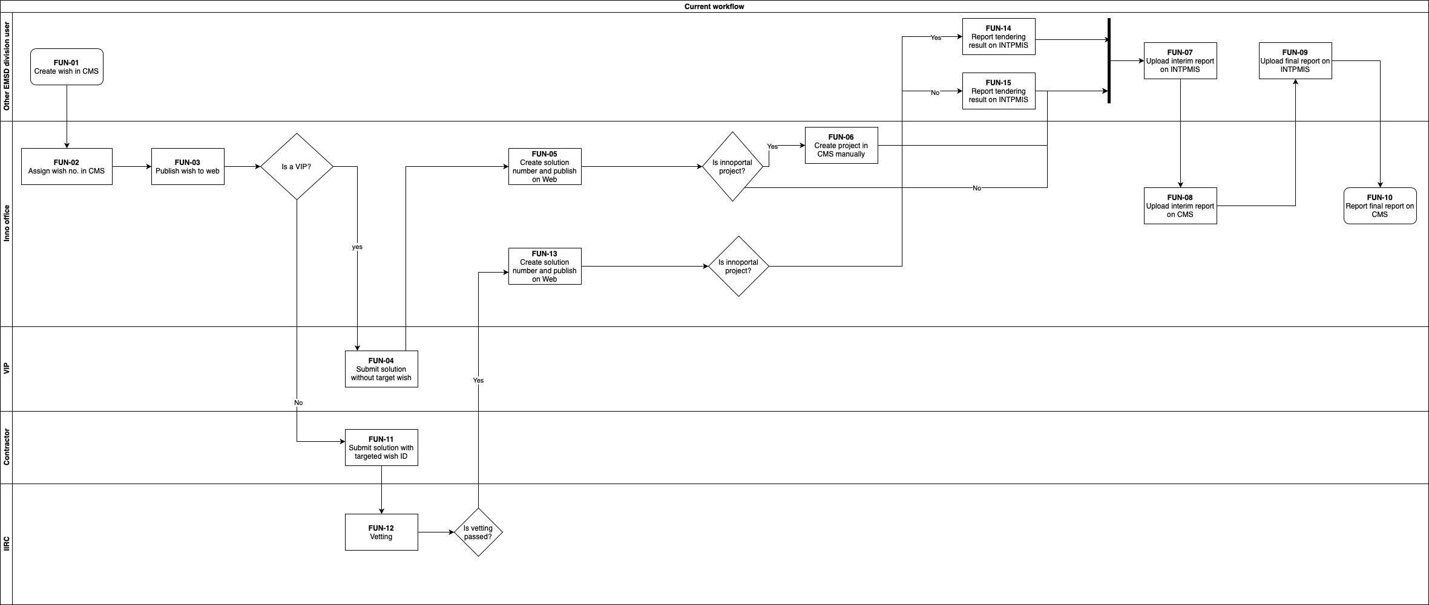

| Task No. | Role | Task Description | Input | Output |
| --- | --- | --- | --- | --- |
| FUN-01 | Other EMSD division user | Create wish in CMS | Fill in wish information | A wish is created with a wish ID (proceed to FUN-02) |
| FUN-02 | Inno office | Assign wish in CMS | Assign the wish | The wish is assigned with a wish number (proceed to FUN-03) |
| FUN-03 | Inno office | Publish wish to web | Input information and publish to web | The wish is published to web (proceed to FUN-04 and FUN-12) |
| FUN-04 | VIP | Submit solution without a targeted wish | Submit solution information without a targeted wish | The solution is uploaded (proceed to FUN-07) |
| FUN-05 | Inno office | Create solution number and publish on web | Create solution number and publish on web | The solution is posted on web  If it is innoproject, proceed to FUN-06.  Otherwise proceed to FUN-07. |
| FUN-06 | Inno office | Create project in CMS manually | Create project in CMS manually | A project is created. (proceed to FUN-07) |
| FUN-07 | Other EMSD division user | Upload interim report on INTPMIS | Upload interim report on INTPMIS | The interim report is uploaded (proceed to FUN-08) |
| FUN-08 | Inno office | Upload interim report on CMS | Upload interim report on CMS | The interim report is uploaded (proceed to FUN-09) |
| FUN-09 | Other EMSD division user | Upload final report on INTPMIS | Upload final report on INTPMIS | The final report is uploaded (proceed to FUN-10) |
| FUN-10 | Inno office | Upload final report on CMS | Upload final report on CMS | The final report is uploaded |
| FUN-11 | Contractor | Submit solution with targeted wish ID | Select a targeted wish with wish ID and wish number  Submit solution information | The solution is uploaded (proceed to FUN-12) |
| FUN-12 | IIRC | Vetting | Proceed technical feasibility assessment | If it is successful, proceed to FUN-13 |
| FUN-13 | Inno office | Create solution number and publish on web | Create solution number and publish on web | The solution is posted on web  If it is innoproject, proceed to FUN-14 |
| FUN-14 | Other EMSD division user | Report tendering result on INTPMIS | Report tendering result on INTPMIS with a solution number and a wish number | The tendering result is reported (proceed to FUN-07) |
| FUN-15 | Other EMSD division user | Report tendering result on INTPMIS | Report tendering result on INTPMIS without a solution number and a wish number | The tendering result is reported (proceed to FUN-07) |

*Current Problems and Issues*

Since the current system mostly involves manual operation, it causes lots of problems and issues, which are described below:

* Time-consuming

Sharing by email to update the project information is not efficient. As the current workflow, when the file is updated, the staff will send the file by email. The colleague has to wait until receiving the email so the data cannot be updated concurrently. Also, when the staff search for a project, multiple Excel files may be checked. It takes time to search for a project.

* Unstructured data

The unstructured data is hard to sort, manage and organize. There may be duplicate copies of data. It causes inaccurate reporting and less informed decisions. Decisions based on poor quality data are not reliable and accurate as those made on assumptions.

* Data loss

Storing data in Excel files without logging history might cause data loss. It costs time and money to restore or recover the data that is essential. The hard copies of information may be located but these may not be up-to-date.

* Low accuracy

The data might not be accurate due to the human error. When a new project is created, the wish information and solution information are copied to the Excel file by manual entry. Spelling, grammar, punctuation, misinterpretation of data, not saving work and mistyping in the wrong fields are all common errors seen in the data entry field.

***Requirements Specification***

*User Requirements*

*Proposed System Overview*

The proposed INTPMIS will address the problems of the current system. Thus, the proposed INTPMIS offers a variety of enhanced aspects as following:

* Working environment

An easy-to-use web portal, UI and forms for admin and users to login and modify individual database entries will be developed. Users are allowed to co-editing of database entries simultaneously and in real-time.

* Data management

The I&T project’s information includes E & M InnoPortal and other I&T projects that will be stored in the MySQL database of INTPMIS. The data includes text ,data ,report and attachment in the form of PDF, Microsoft Word and JPEG, PNG etc. Users can access the data in the INTPMIS web portal. Moreover, it migrates existing I&T project information by interface with other systems and from Excel tables.

* Data analysis

The reports and statistics will be generated by the system to show the facts and trend of I&T development. Also, users can customize the reports. Filtering and Sorting record functions will be added to the system. Users can export the data to Excel reports.

* Workflow

When creating a new project, users do not need to enter the data manually. The system will automatically get the data from different tables. It avoids data loss and increases accuracy.

*Future Business Process*

List of Future Business Process:

| Process ID | Business Process Title |
| --- | --- |
| BP-01 | User Login |
| BP-02 | View Project List |
| BP-03 | Create Project |
| BP-04 | View and Edit Project |
| BP-05 | View Wish List |
| BP-06 | View and Edit Wish |
| BP-07 | View Solution List |
| BP-08 | View and Edit Solution |
| BP-09 | View Report List |
| BP-10 | View Report |
| BP-11 | View Log List |
| BP-12 | Upload File |

*UI & UX Design*

*Login page*

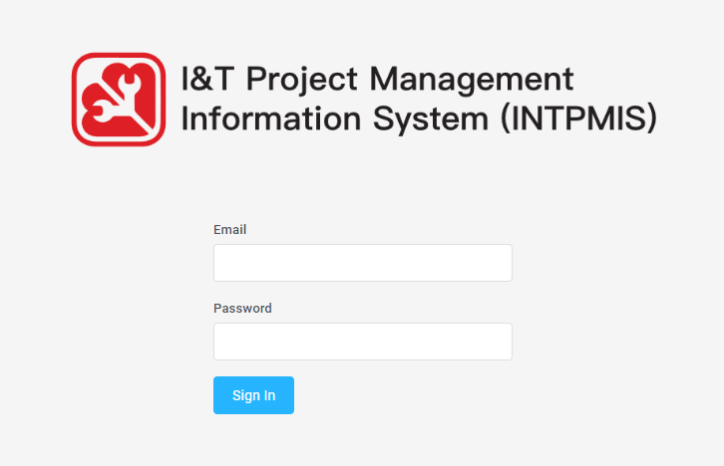

*Project Management- Create*

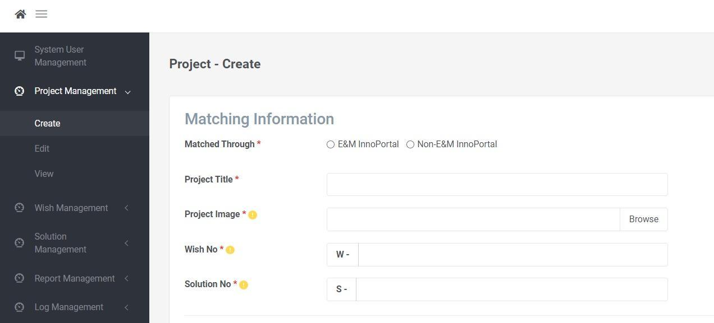

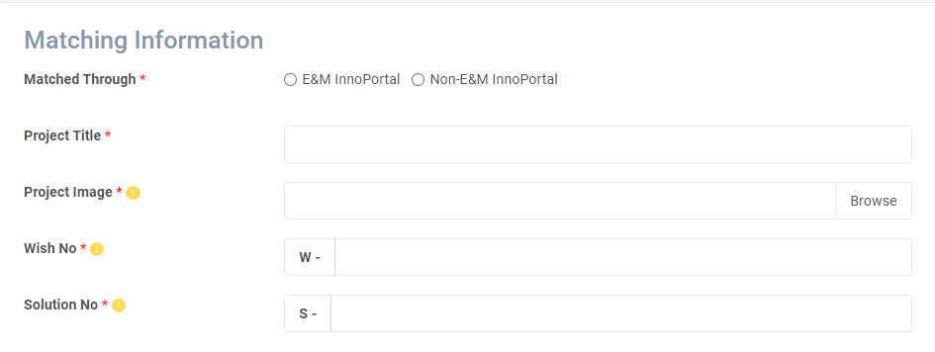

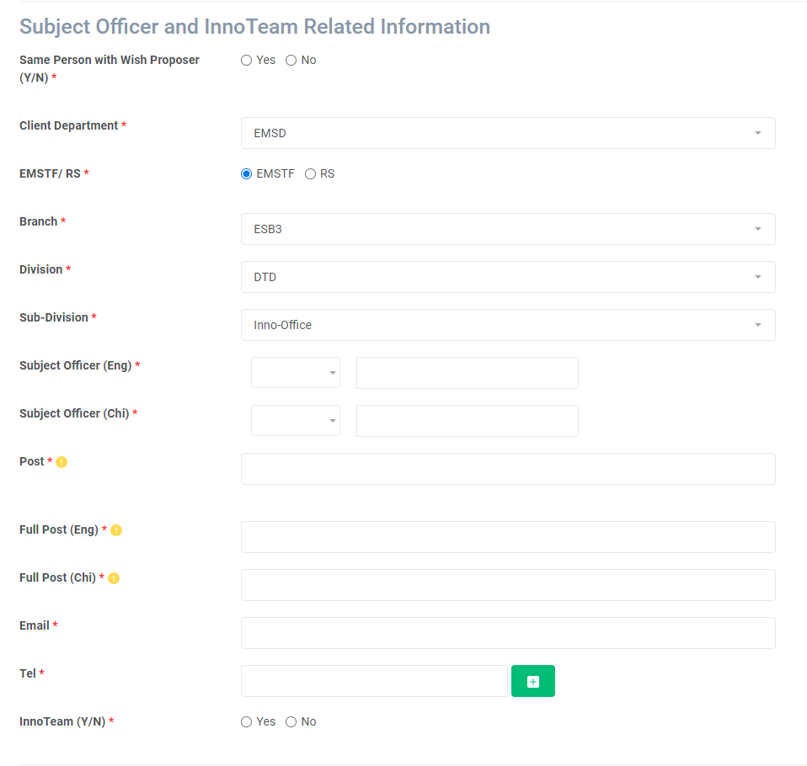

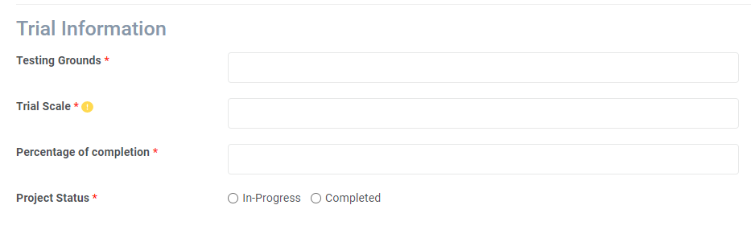

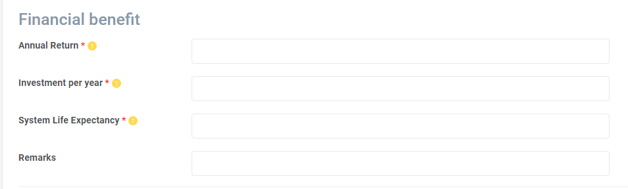

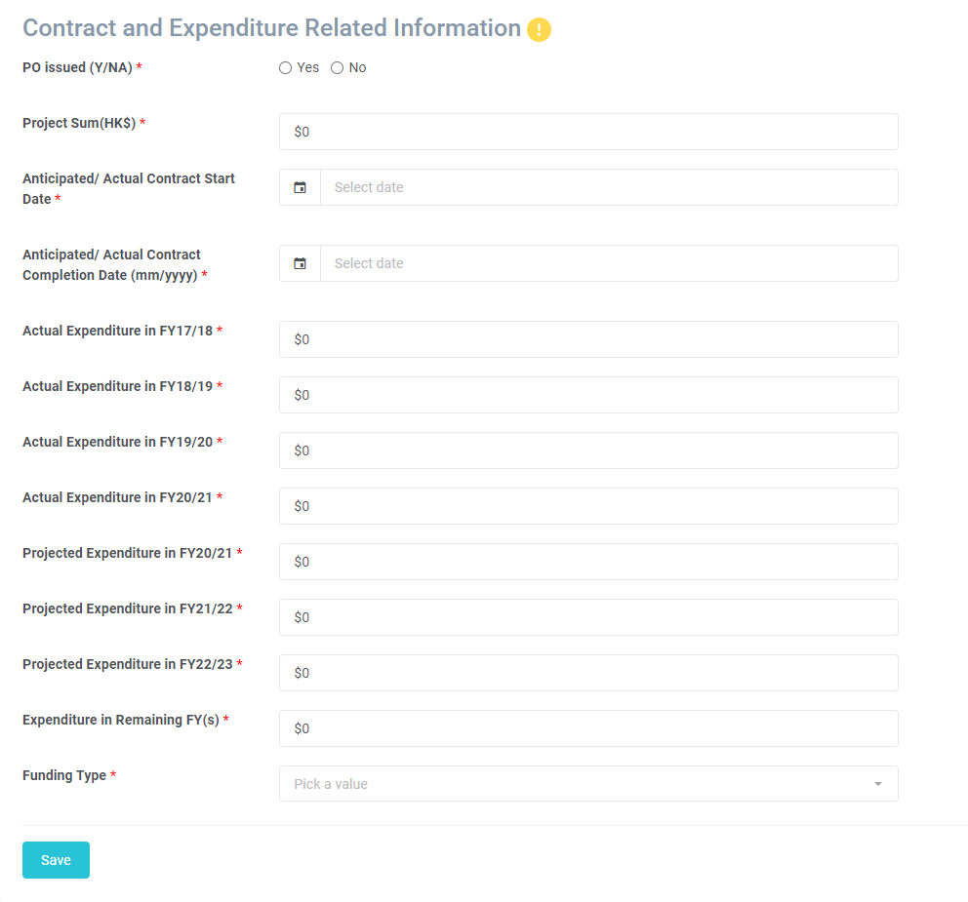

*Project Management- Edit*

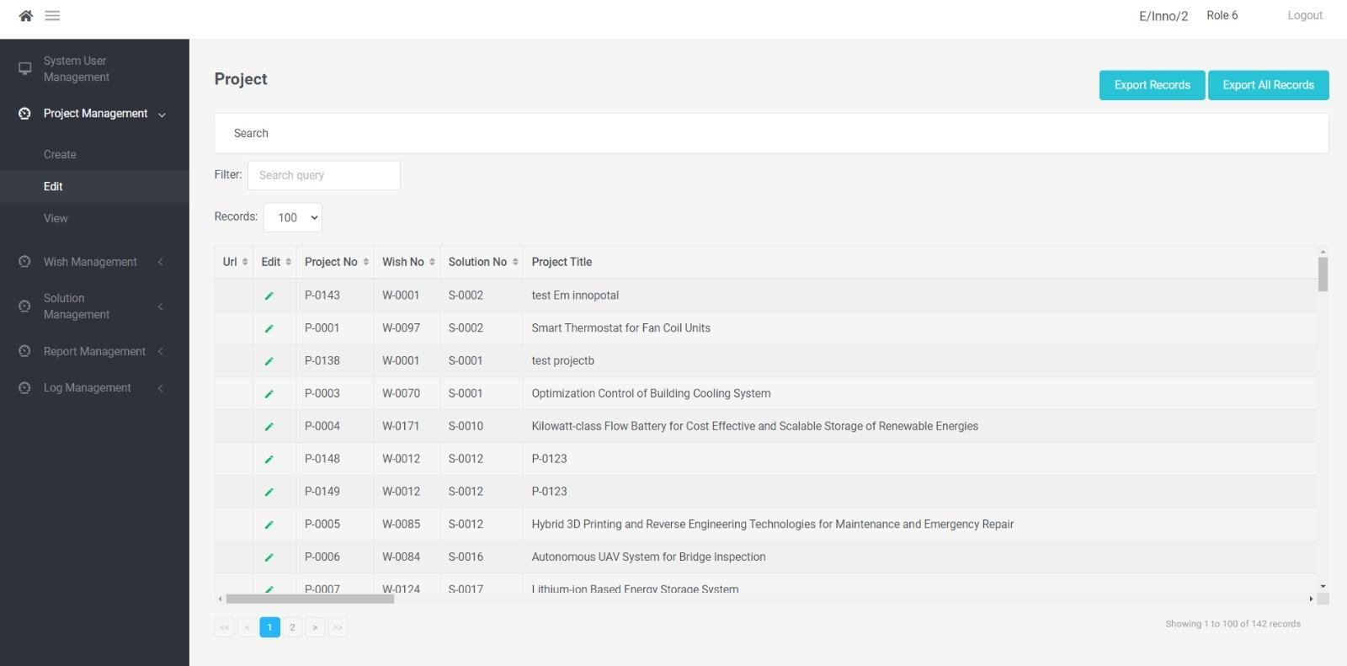

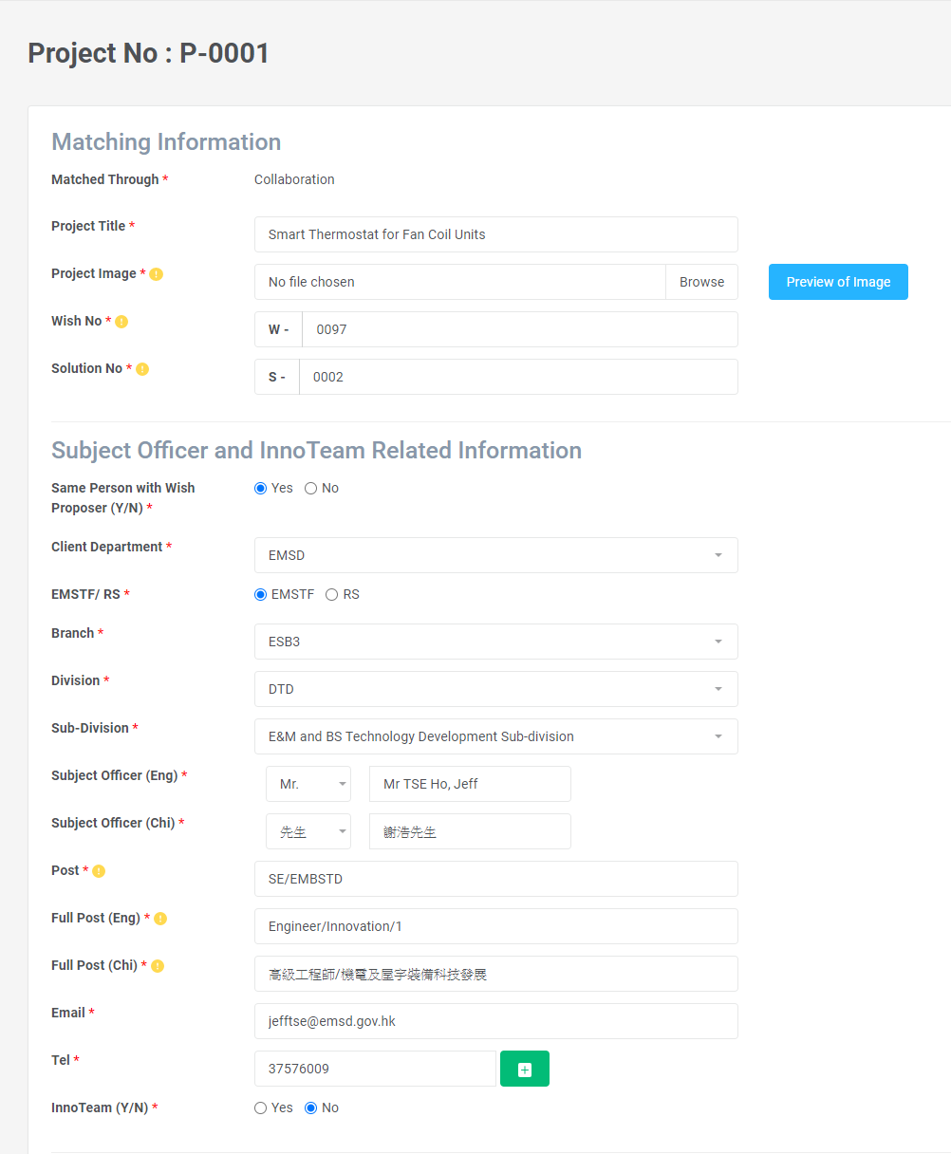

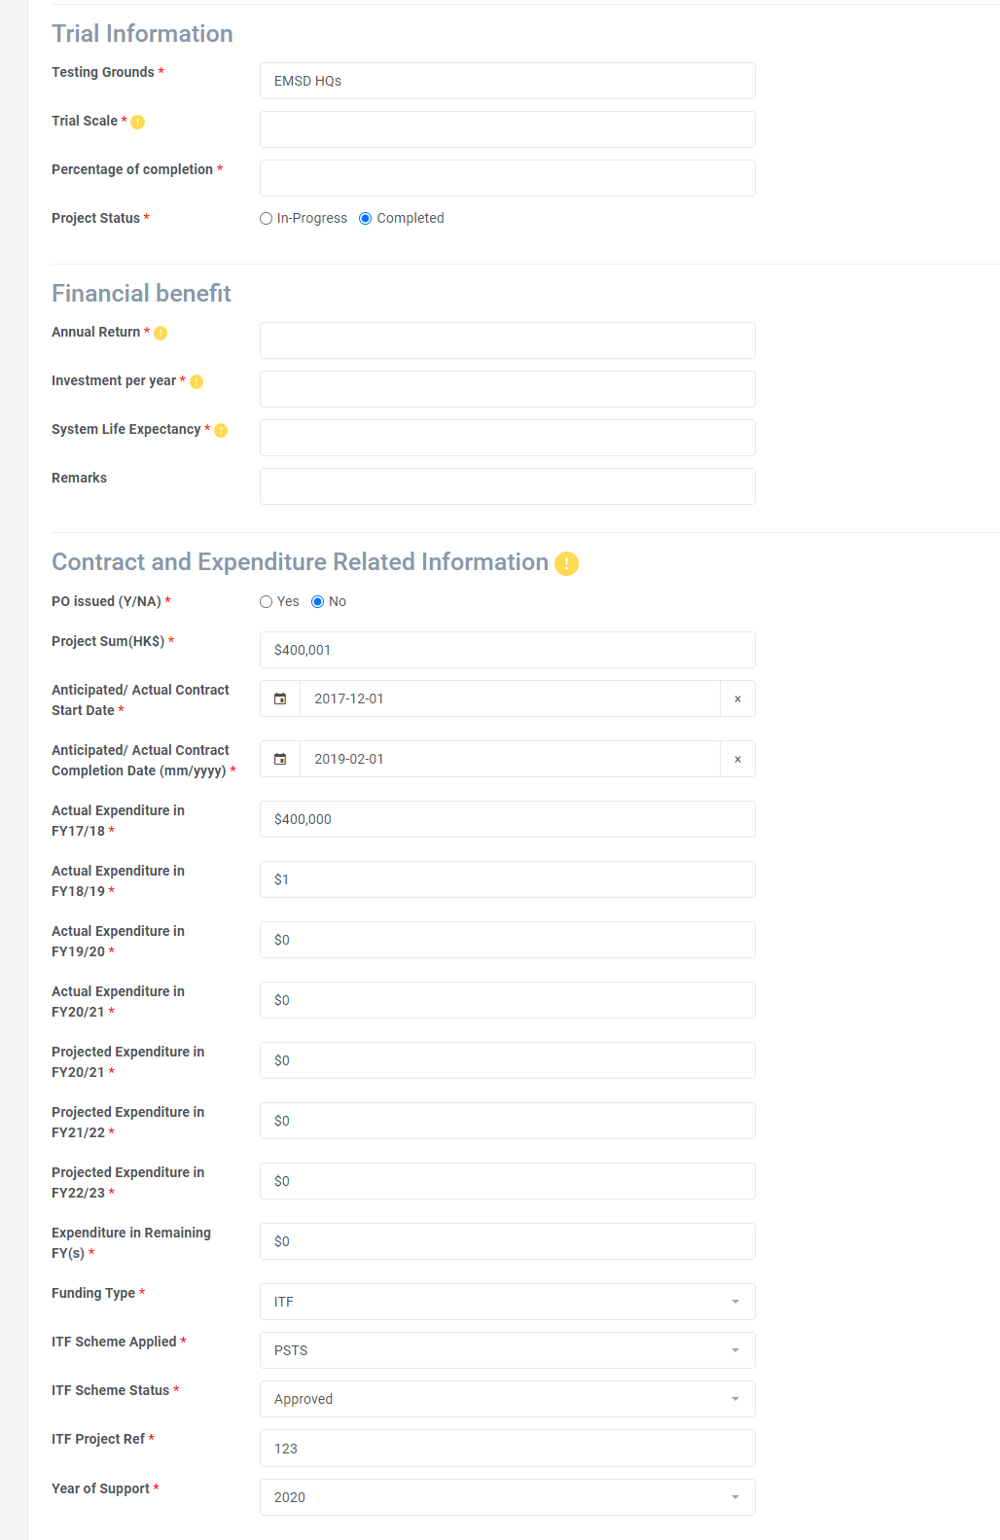

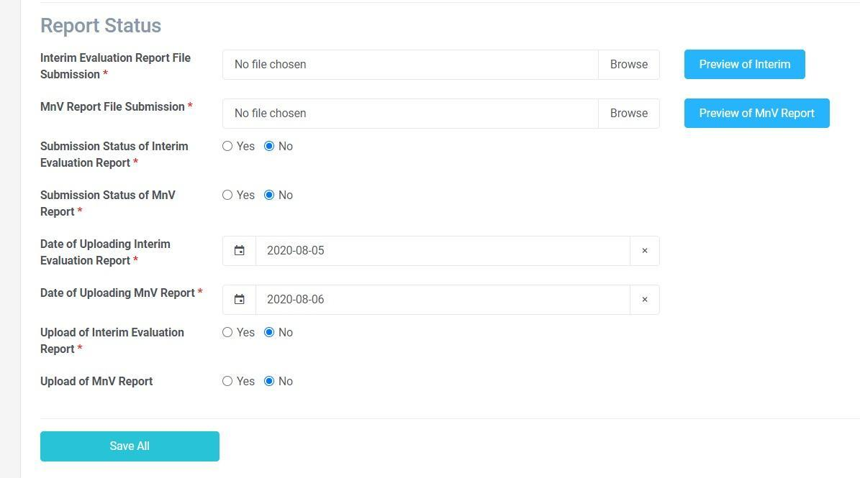

*Project Management- View*

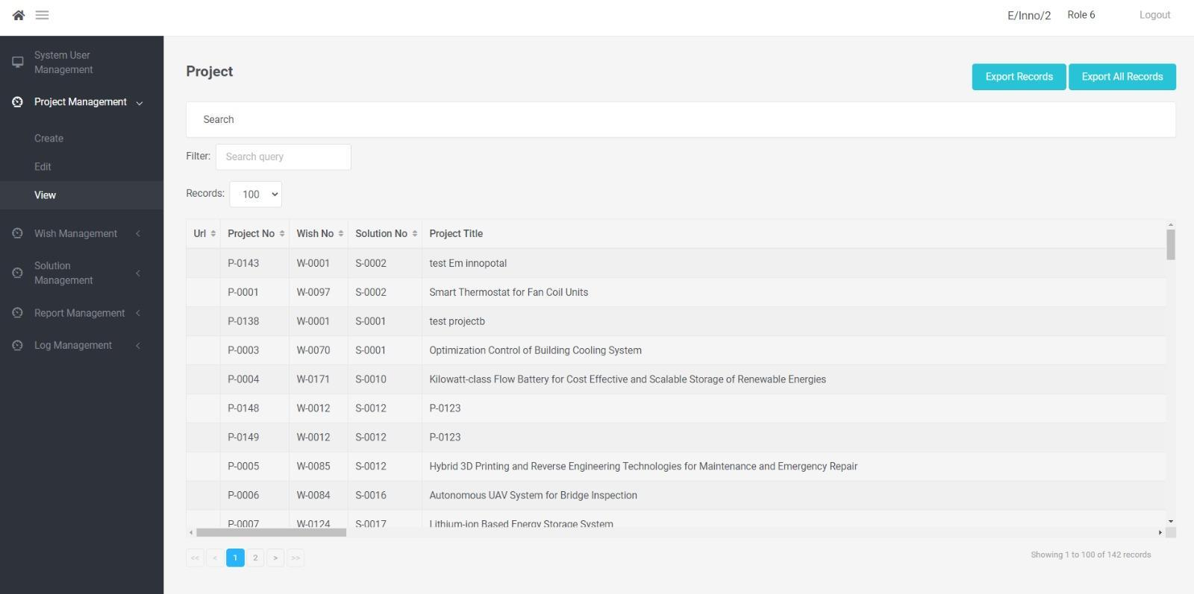

*Wish Management- Edit*

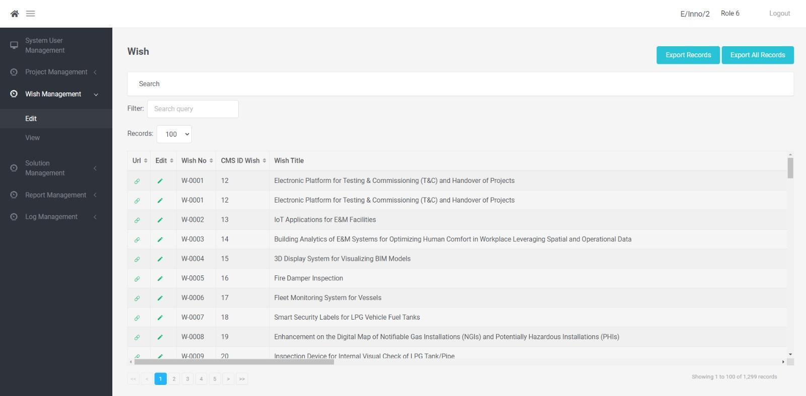

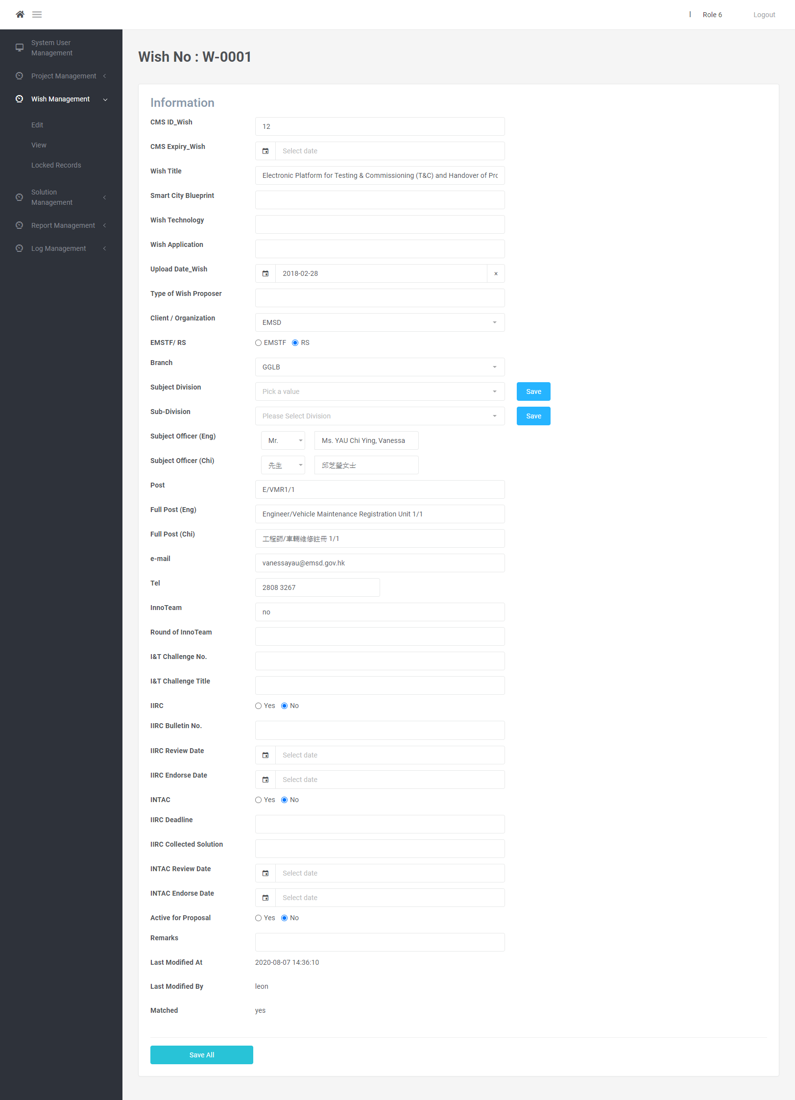

*Wish Management- View*

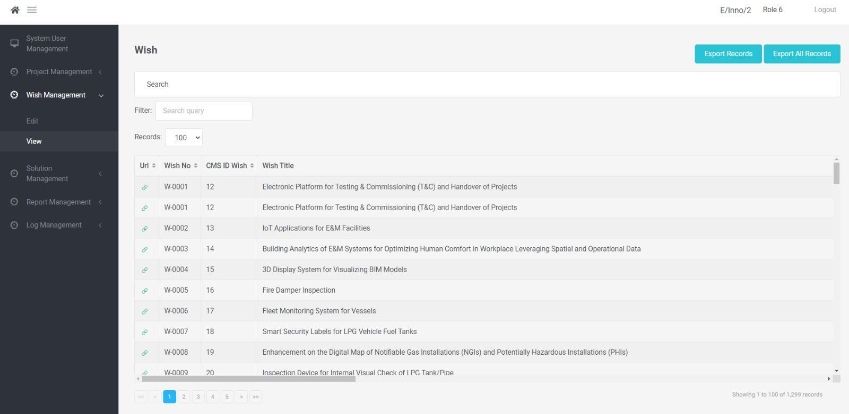

*Solution Management- Edit*

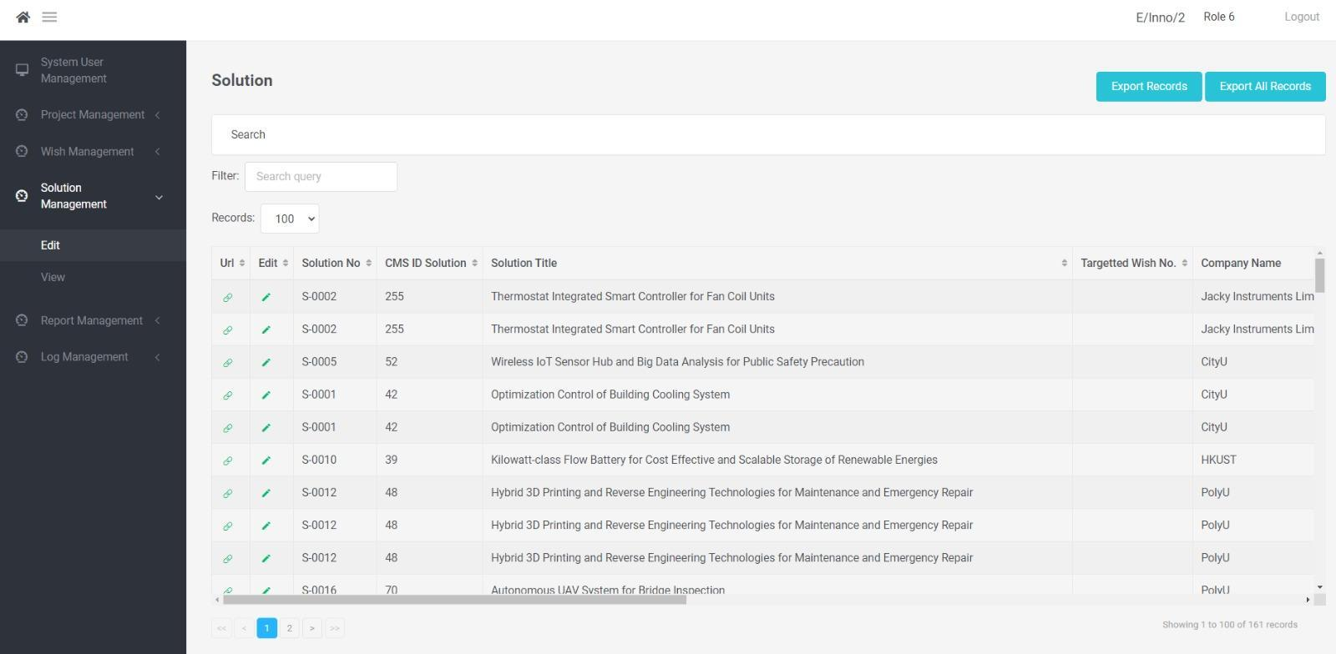

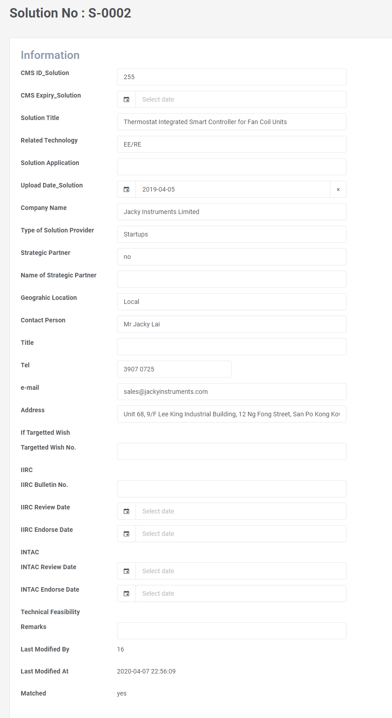

*Solution Management- View*

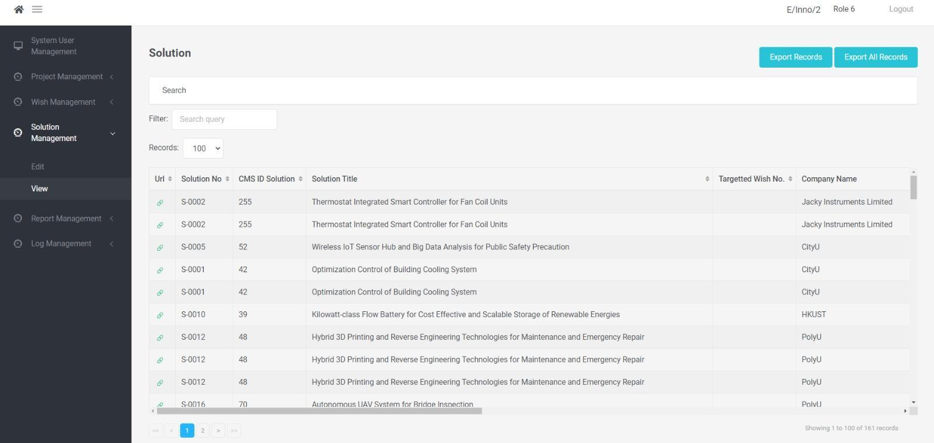

*Report Management- View*

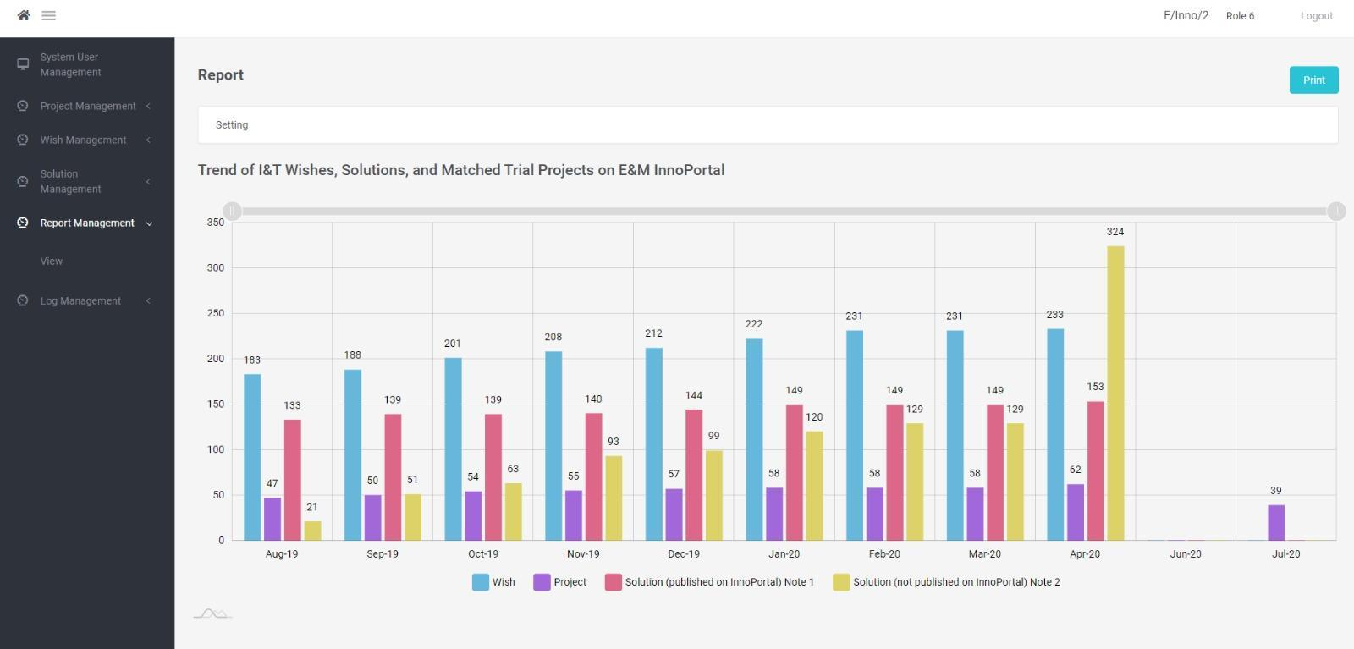

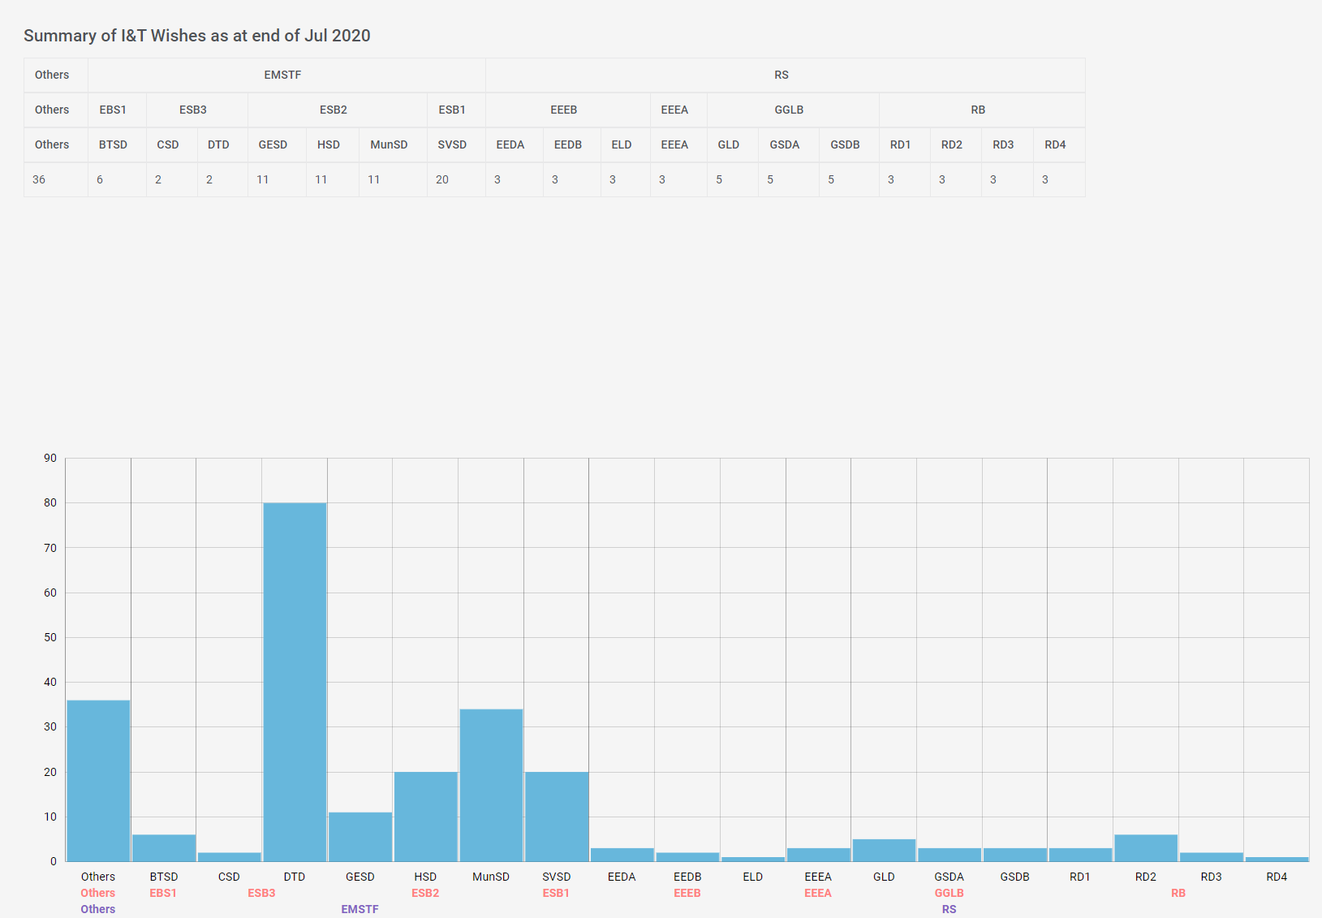

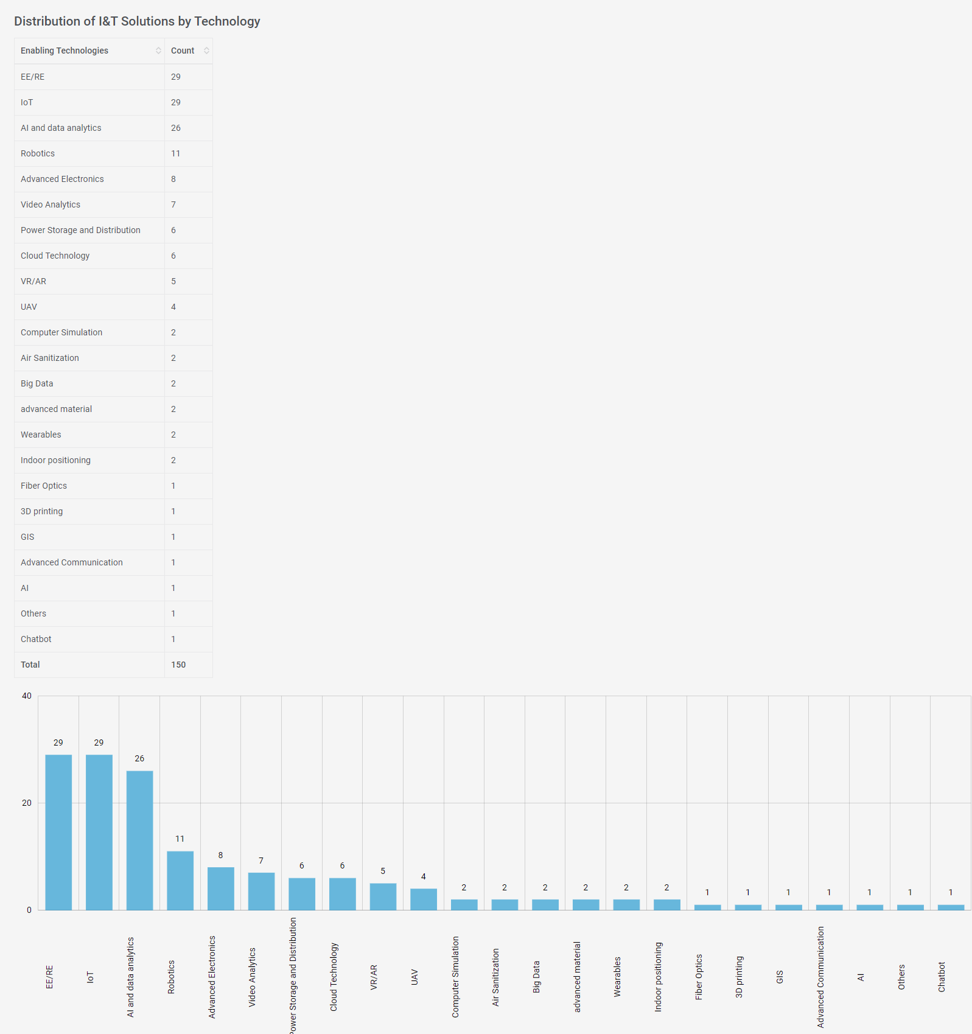

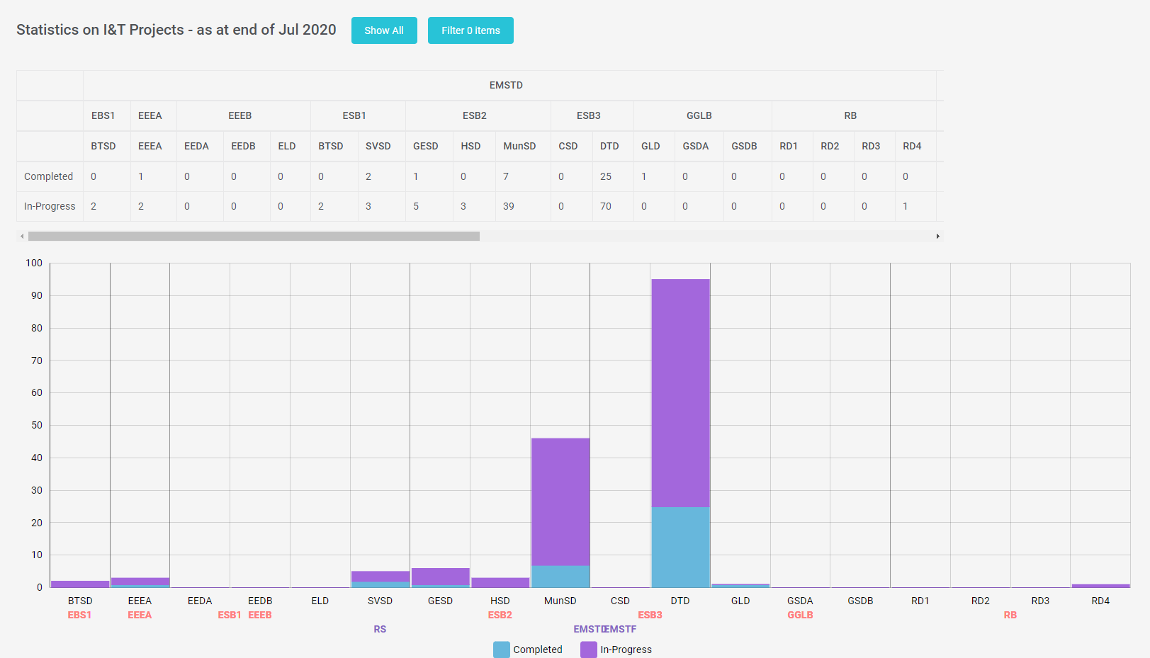

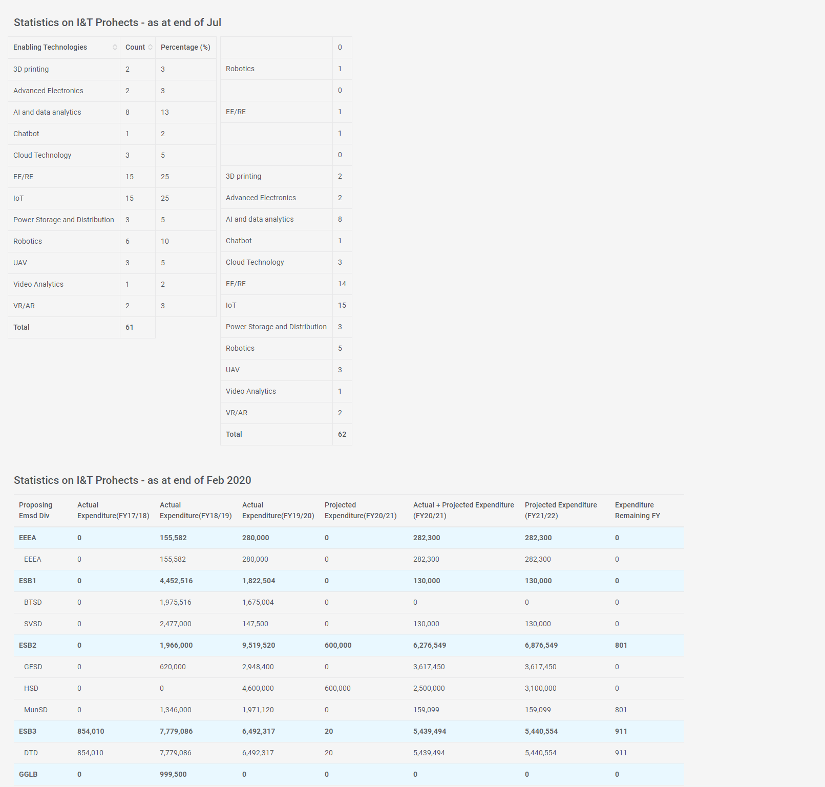

*Log Management- View*

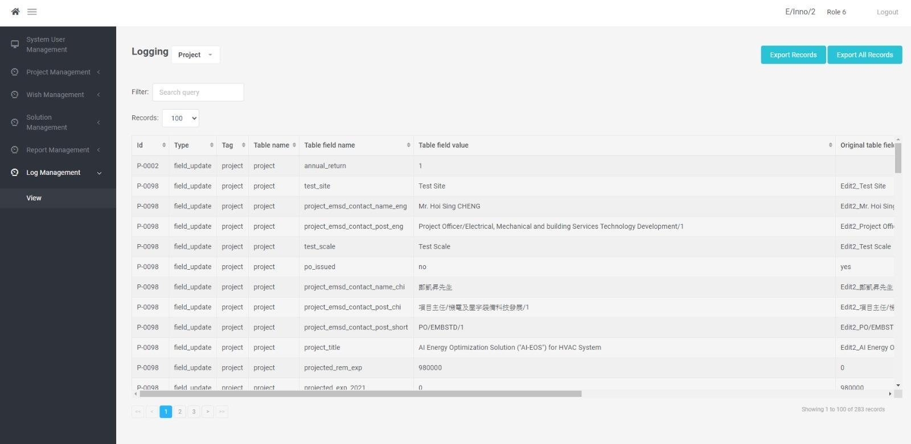

*Functional Requirements*

*List of Functional Requirements:*

| Req. ID | Requirement Title | Target Users | Priority |
| --- | --- | --- | --- |
| REQ-SYS-001 | Login | Users | MUST |
| REQ-SYS-002 | Project List | Users | MUST |
| REQ-SYS-003 | Create a Project | Users | MUST |
| REQ-SYS-004 | View or Edit a Project | Users | MUST |
| REQ-SYS-005 | Wish List | Users | MUST |
| REQ-SYS-006 | View or Edit a Wish | Users | MUST |
| REQ-SYS-007 | Solution List | Users | MUST |
| REQ-SYS-008 | View and Edit a Solution | Users | MUST |
| REQ-SYS-009 | Report List | Users | MUST |
| REQ-SYS-010 | View Report | Users | MUST |
| REQ-SYS-011 | Log List | Users | MUST |
| REQ-SYS-012 | View Log List | Users | MUST |
| REQ-SYS-013 | Upload File | Users | MUST |

*REQ-SYS-001 - Login*

| Item | Description |
| --- | --- |
| Requirement ID | REQ-SYS-001 |
| Requirement Title | Login |
| Priority | MUST |
| Functional Requirement Description | * The system should support single sign on through the Windows Active Directory * Support Existing User Permission Matrix Mapping * If the user is an Acting of another user according to the LDAP login details, there should be an option for the user to choose whether to access the INTPMIS as the role of Acting or the original role of the user |
| Frequency of Use | Daily |
| Acceptance Criteria | * Correct permission is granted according to the LDAP login details. |
| Related Business Process | BP-01 |

*REQ-SYS-002 - Project List*

| Item | Description |
| --- | --- |
| Requirement ID | REQ-SYS-002 |
| Requirement Title | Project List |
| Priority | MUST |
| Functional Requirement Description | * A page allows users to search for the projects * Support sorting and filtering * Allow to export the project list result in file type ".csv" in the Project page * Allow to configure the filtering and sorting criteria * Allow to view / edit project |
| Frequency of Use | Daily |
| Acceptance Criteria | * Projects are correctly shown according to the filtering and sorting * The records in the exported project list are shown correctly according to the project list result * File downloaded in the correctly format and naming * Filtering options are shown correctly according to the configuration * Project list is sorted by default correctly according to the sorting configuration * User can view / edit project by clicking the icon |
| Related Business Process | BP-02 |

*REQ-SYS-003 - Create a Project*

| Item | Description |
| --- | --- |
| Requirement ID | REQ-SYS-003 |
| Requirement Title | Create a Project |
| Priority | MUST |
| Functional Requirement Description | Allow users to create a project |
| Frequency of Use | Occasionally |
| Acceptance Criteria | * Redirection to the page the project table when the project creation is successful * Project ID is successfully generated when the necessary information is filled and saved/submitted |
| Related Business Process | BP-03 |

*REQ-SYS-004 - View and Edit a Project*

| Item | Description |
| --- | --- |
| Requirement ID | REQ-SYS-004 |
| Requirement Title | View or Edit a Project |
| Priority | MUST |
| Functional Requirement Description | * Support read-only and edit mode the permission of the user |
| Frequency of Use | Daily |
| Acceptance Criteria | * The interactable objects are shown and enabled correctly according to the stage of the project * The information is shown correctly according to the stage of the project and the permission of the user * Fields are editable according to the Field Rule |
| Related Business Process | BP-04 |

*REQ-SYS-005 - Wish List*

| Item | Description |
| --- | --- |
| Requirement ID | REQ-SYS-005 |
| Requirement Title | Wish List |
| Priority | MUST |
| Functional Requirement Description | * A page allows users to search for the wishes * Support sorting and filtering * Allow to export the wish list result in file type ".csv" in the Wish page * Allow to configure the filtering and sorting criteria * Allow to view / edit wish |
| Frequency of Use | Daily |
| Acceptance Criteria | * Wishes are correctly shown according to the filtering and sorting * The records in the exported wish list are shown correctly according to the wish list result * File downloaded in the correctly format and naming * Filtering options are shown correctly according to the configuration * Wish list is sorted by default correctly according to the sorting configuration * User can view / edit wish by clicking the icon |
| Related Business Process | BP-05 |

*REQ-SYS-006 - View or Edit a Wish*

| Item | Description |
| --- | --- |
| Requirement ID | REQ-SYS-006 |
| Requirement Title | MUST |
| Priority | * Support read-only and edit mode the permission of the user |
| Frequency of Use | Daily |
| Functional Requirement Description | * The interactable objects are shown and enabled correctly according to the stage of the project * The information is shown correctly according to the stage of the project and the permission of the user * Fields are editable according to the Field Rule |
| Acceptance Criteria | High |
| Related Business Process | BP-06 |

*REQ-SYS-007 - Solution List*

| Item | Description |
| --- | --- |
| Requirement ID | REQ-SYS-007 |
| Requirement Title | Solution List |
| Priority | MUST |
| Functional Requirement Description | * A page allows users to search for the solutions * Support sorting and filtering * Allow to export the solution list result in file type ".csv" in the Solution page * Allow to configure the filtering and sorting criteria * Allow to view / edit solution |
| Frequency of Use | Daily |
| Acceptance Criteria | * Solutions are correctly shown according to the filtering and sorting * The records in the exported project list are shown correctly according to the solution list result * File downloaded in the correctly format and naming * Filtering options are shown correctly according to the configuration * Solution list is sorted by default correctly according to the sorting configuration * User can view / edit solution by clicking the icon |
| Related Business Process | BP-07 |

*REQ-SYS-008 - View and Edit a Solution*

| Item | Description |
| --- | --- |
| Requirement ID | REQ-SYS-008 |
| Requirement Title | View or Edit a Solution |
| Priority | MUST |
| Functional Requirement Description | * Support read-only and edit mode the permission of the user |
| Frequency of Use | Daily |
| Acceptance Criteria | * The interactable objects are shown and enabled correctly according to the stage of the solution * The information is shown correctly according to the stage of the solution and the permission of the user * Fields are editable according to the Field Rule |
| Related Business Process | BP-08 |

*REQ-SYS-009 - Report List*

| Item | Description |
| --- | --- |
| Requirement ID | REQ-SYS-009 |
| Requirement Title | Report List |
| Priority | MUST |
| Functional Requirement Description | * Support sorting and filtering * Allow to export the report list result in file type ".csv" in the Report page * Allow to configure the filtering and sorting criteria * Allow to view / edit report |
| Frequency of Use | Daily |
| Acceptance Criteria | * Reports are correctly shown according to the filtering and sorting * The records in the exported report list are shown correctly according to the report list result * File downloaded in the correctly format and naming * Filtering options are shown correctly according to the configuration * Report list is sorted by default correctly according to the sorting configuration |
| Related Business Process | BP-09 |

*REQ-SYS-010 - View Report*

| Item | Description |
| --- | --- |
| Requirement ID | REQ-SYS-010 |
| Requirement Title | View Report |
| Priority | MUST |
| Functional Requirement Description | * Support read-only mode the permission of the user |
| Frequency of Use | Daily |
| Acceptance Criteria | * The interactable objects are shown and enabled correctly according to the stage of the report * The information is shown correctly according to the stage of the report |
| Related Business Process | BP-10 |

*REQ-SYS-011 - Log List*

| Item | Description |
| --- | --- |
| Requirement ID | REQ-SYS-011 |
| Requirement Title | Log List |
| Priority | High |
| Functional Requirement Description | * Support sorting and filtering * Allow to export the log list result in file type ".csv" in the Report page * Allow to configure the filtering and sorting criteria * Allow to view / edit log |
| Frequency of Use | Daily |
| Acceptance Criteria | * Logs are correctly shown according to the filtering and sorting * The records in the exported log list are shown correctly according to the log list result * File downloaded in the correctly format and naming * Filtering options are shown correctly according to the configuration * Log list is sorted by default correctly according to the sorting configuration |
| Related Business Process | BP-11 |

*REQ-SYS-012 - View Log List*

| Item | Description |
| --- | --- |
| Requirement ID | REQ-SYS-012 |
| Requirement Title | View Log List |
| Priority | MUST |
| Functional Requirement Description | * Support read-only mode the permission of the user |
| Frequency of Use | Daily |
| Acceptance Criteria | * The interactable objects are shown * The information is shown correctly |
| Related Business Process | BP-11 |

*REQ-SYS-013 - Upload Files*

| Item | Description |
| --- | --- |
| Requirement ID | REQ-SYS-013 |
| Requirement Title | Upload Files |
| Priority | MUST |
| Functional Requirement Description | * Allow users to upload multiple formats of files, such as pdf, jpeg, docx, xls * Users can replace the files * The files can be deleted |
| Frequency of Use | Daily |
| Acceptance Criteria | * Files can successfully be uploaded * The documents are successfully uploaded according to the system limits (e.g. files types and file size) |
| Related Business Process | BP-12 |

*Non-functional Requirements*

*List of Functional Requirements*

| **Req. ID** | **Category** | **Requirement Title** | **Target Users** | **Priority** |
| --- | --- | --- | --- | --- |
| REQ-SR-001 | System Requirements | Response Time | User | M |
| REQ-SR-002 | System Requirements | Service Time | User | M |
| REQ-SR-003 | System Requirements | Export | User | M |
| REQ-SR-004 | System Requirements | Scalability | User | M |
| REQ-SR-005 | System Requirements | System Performance | User | M |
| REQ-UR-001 | User Requirements | User Interface Requirement | User | M |
| REQ-SCR-001 | System Controls Requirements | Function Access Rights | User | M |
| REQ-SCR-002 | System Controls Requirements | Access to Data | User | M |
| REQ-SCR-003 | System Controls Requirements | System Backup | User | M |

*REQ-SR-001 Response Time*

Requirements Description:

| Item | Description |
| --- | --- |
| Requirement ID | REQ-SR-001 |
| Category | System Requirements |
| Requirement title | Response Time |
| Priority | M |
| Non-functional requirement description | The response time for predefined query should be 95% within 5 seconds, subject to confirmation of the selected technical solution. |

*REQ-SR-002 Service Time*

Requirements Description:

| Item | Description |
| --- | --- |
| Requirement ID | REQ-SR-002 |
| Category | System Requirements |
| Requirement title | Service Time |
| Priority | M |
| Non-functional requirement description | 1. The access to the new system would be 08:00 to 20:00 daily, and late night provisionally. 7x24 availability is not required. 2. Achieve availability of 99.0% (i.e. unscheduled downtime could not exceed 7.2 minutes per day or 1.83 days per year on average). |

*REQ-SR-003 Export*

Requirements Description:

| Item | Description |
| --- | --- |
| Requirement ID | REQ-SR-003 |
| Category | System Requirements |
| Requirement title | Export |
| Priority | M |
| Non-functional requirement description | Allow data of tables to be exported in different external easy-readable formats such as Excel. |

*REQ-SR-004 Scalability*

Requirements Description:

| Item | Description |
| --- | --- |
| Requirement ID | REQ-SR-004 |
| Category | System Requirements |
| Requirement title | Scalability |
| Priority | M |
| Non-functional requirement description | Provide scalability options of hardware, software, etc. for future system expansion. |

*REQ-SR-005 System Performance*

Requirements Description:

| Item | Description |
| --- | --- |
| Requirement ID | REQ-SR-005 |
| Category | System Requirements |
| Requirement title | System Performance |
| Priority | M |
| Non-functional requirement description | Provide technically sound architecture to meet response time and agreed performance level. |

*REQ-UR-001 User Interface Requirement*

Requirements Description:

| Item | Description |
| --- | --- |
| Requirement ID | REQ-UR-001 |
| Category | User Requirements |
| Requirement title | User Interface Requirement |
| Priority | M |
| Non-functional requirement description | 1. The user-interfaces and graphical user interface (GUI) must be user-friendly. Based on the user profile, personalised views can be provided. The interface of the solution should be consistent with web-based applications. 2. Adopt responsive web design to adjust layout according to different screen sizes in order to facilitate users’ browsing experience in devices including but not limited to desktops, tablets and mobile phones. 3. Function and display properly in multiple browsers including Internet Explorer and Chrome with Apollo support version. |

*REQ-SCR-001 Function Access Rights*

Requirements Description:

| Item | Description |
| --- | --- |
| Requirement ID | REQ-SCR-001 |
| Category | System Controls Requirements |
| Requirement title | Function Access Rights |
| Priority | M |
| Non-functional requirement description | Able to define various user access rights of functions according to operations or user levels (access right can be assigned to the user group or individual user). |

*REQ-SCR-002 Access to Data*

Requirements Description:

| Item | Description |
| --- | --- |
| Requirement ID | REQ-SCR-002 |
| Category | System Controls Requirements |
| Requirement title | Access to Data |
| Priority | M |
| Non-functional requirement description | 1. Able to define access rights for users to access particular data and also on a conditional basis. 2. Able to define access monitoring for the selected data. |

*REQ-SCR-003 System Backup*

Requirements Description:

| Item | Description |
| --- | --- |
| Requirement ID | REQ-SCR-003 |
| Category | System Controls Requirements |
| Requirement title | System Backup |
| Priority | M |
| Non-functional requirement description | Able to meet general backup requirements including data and system; and all audit logging information. |

*Technical Requirements*

*List of Technical Requirements:*

| Req. ID | Requirement Title | Priority | Category |
| --- | --- | --- | --- |
| TR-SBR-001 | Server House Keeping | M | System Backup and Recovery Requirements |
| TR-SBR-002 | Backup, Recovery and System Archive | M | System Backup and Recovery Requirements |
| TR-DRR-001 | System disaster recovery | M | Disaster Recovery Requirements |

*TR-SBR-001 Server House Keeping*

Technical requirements description:

| Item | Description |
| --- | --- |
| Requirement ID | TR-SBR-001 |
| Requirement title | Server House Keeping |
| Priority | M |
| Category | System Backup and Recovery Requirements |
| Technical requirement description | System logs must be archived to backup tape weekly |

*TR-SBR-002 Backup, Recovery and System Archive*

Technical requirements description:

| Item | Description |
| --- | --- |
| Requirement ID | TR-SBR-002 |
| Requirement title | Backup, Recovery and System Archive |
| Priority | M |
| Category | System Backup and Recovery Requirements |
| Technical requirement description | 1. Provide daily backup 2. Provide weekly system backup 3. Provide 2 generations of system backup stored off-site 4. Provide system activity logs and reports |

*TR-DRR-001 System Disaster Recovery*

Technical requirements description:

| Item | Description |
| --- | --- |
| Requirement ID | TR-DRR-001 |
| Requirement title | System Disaster Recovery |
| Priority | M |
| Category | System Backup and Recovery Requirements |
| Technical requirement description | 1. Participate in the disaster recovery activities and complete all activities assigned following the procedures in the disaster recovery plan. 2. Co-ordinate with new system user to participate in the disaster recovery activities. 3. Resume the whole system from disaster recovery site to normal production environment. |

***System Specification***

| Item | Category | System Functions |
| --- | --- | --- |
| 1 | Information Viewing | View Project List and Detail |
| 2 | Content Management | Create a Project |
| 3 | Content Management | Edit a Project |
| 4 | Information Viewing | Search Projects |
| 5 | Information Viewing | Filter Projects |
| 6 | Workflow Application | Export Projects |
| 7 | Information Viewing | View Wish List and Detail |
| 8 | Content Management | Edit a Wish |
| 9 | Information Viewing | Search Wishes |
| 10 | Information Viewing | Filter Wishes |
| 11 | Workflow Application | Export Wishes |
| 12 | Information Viewing | View Solution List and Detail |
| 13 | Content Management | Edit a Solution |
| 14 | Information Viewing | Search Solutions |
| 15 | Information Viewing | Filter Solutions |
| 16 | Workflow Application | Export Solutions |
| 17 | Information Viewing | View Report List and Detail |
| 18 | Workflow Application | Export Report |
| 19 | Information Viewing | View Log List and Detail |
| 20 | Content Management | Cancel Reminder for Log |

***Architecture Design***



The proposed INTPMIS is a web-based application which is built using Node.js, Vue.js, and MySQL. INTPMIS is designed for bridging the information and collaboration between different users. It interfaces with the online platform E&M InnoPortal to obtain relevant project

data, such as the wish table, project table, and solution table, stored in INTPMIS MySQL database. Users are allowed to fill information and match records via the web user interface which is built by Vue.js. The key features of the system are record searching, record filtering, and report generation.

***Selected Technical System Option***

Node.js and MySQL are applied for the backend of the system when the Vue.js is the frontend of the system.

Node.js is an open source, cross-platform runtime environment for developing server-side and networking applications. Node.js applications are written in JavaScript, and can be run within the Node.js runtime on OS X, Microsoft Windows, and Linux.

Node.js also provides a rich library of various JavaScript modules which simplifies the development of web applications using Node.js to a great extent.

MySQL is an open source relational database management system. It is based on the structure query language (SQL), which is used for adding, removing, and modifying information in the database.

Vue.js is a library for building interactive web interfaces. The goal of Vue.js is to provide the benefits of reactive data binding and composable view components with an API that is as simple as possible.

***Hardware & Software Procurement***

*Hardware Procurement*

UAT stage:

App Server

OS Windows Server 2019

CPU 2.8 quad-core GHz

RAM 8 GB

Disk 100 GB

Database Server

OS Windows Server 2019

CPU 2.8 quad-core GHz

RAM 8 GB

Disk 150 GB

Production stage:

App Server

OS Windows Server 2019

CPU 2.8 quad-core GHz

RAM 8 GB

Disk 100 GB

Database Server

OS Windows Server 2019

CPU 2.8 quad-core GHz

RAM 8 GB

Disk 150 GB

*Software Procurement*

N/A

***Programme Flow with Pseud-code Based, Software Module and Wireframe Mock-up***

| **Mock-up** | **Pseud-code** |
| --- | --- |
| SSO Login | |
| User gets an authentication ID from EMSD Active Directory. Then the system will call LDAP API to get users authentication code and information by the staff ID.  If login is successful, the landing page will be shown.  Otherwise, the user name login page will be shown. | |
| User name Login | |
|  | 1. Open a browser (Internet Explorer/ Chrome)  2. Go to http://intpmis/#/login  3. Input email address and password  4. click "Sign In" button |
|  | Case 1: Login successfully  The page is navigated to the landing page |
|  | Case 2: Login fail  The error prompt is shown. |
| Create Project | |
|  | Click “Create” under “Project Management" |
|  | 1. Fill the required fields  2. Click “Submit” button |
|  | Case 1: Input field is not filled  The error message is shown under the field |
|  | Case 2: Value is not valid  The error message is shown |
|  | Case 3: Project is created successfully  A successful message is shown with the project number  1. Click “X” to redirect to project view page |
| Edit Project | |
|  | 1. Click “Edit” under “Project Management”  2. Click edit icon to edit the project |
|  | To edit information of the project, users can:  1. select completed  2. input values  3. empty input  Then click “Save All” button |
|  | Case 1: Invalid input  The alert message is shown |
|  | Case 2: Save successfully  The successful message is shown |
| View Project | |
|  | 1. Click “View” under “Project Management”  2. Scoll the bottom bar to the right to show the project detail |
| Filter Project | |
|  | 1. Input filter value  2. Select display number of record per page  3. The results are shown |
| Search Project | |
|  | 1. Click search section  2. Select search criteria  3. Select values of criteria  4. Click “Search” button  5. The results are shown |
| Export Project | |
|  | There are two options for exporting project  1. Export searched records   * Click “Export Records” button   2. Export all records   1. Click “Export All Records” button   The exported results will be stored in a csv file |
| Edit Wish | |
|  | 1. Input value to edit  2. Click “Save All” button |
|  | Case 1: Invalid input  An alert message is shown |
|  | Case 2: Wish is edited successfully  An alert message is shown |
| View Wish | |
|  | 1. Click “View” under “Wish Management”  2. Scroll the bottom bar to right to view detail of the wish |
| Search Wish | |
|  | 1. Click search section  2. Select search criteria  3. Select values of criteria  4. Click “Search” button  5. The results are shown |
| Filter Wish | |
|  | 1. Input filter value  2. Select display number of record per page  3. The results are shown |
| Export Wish | |
|  | There are two options for exporting wish  1. Export searched records   * Click “Export Records” button   2. Export all records   1. Click “Export All Records” button   The exported results will be stored in a csv file |
| Edit Solution | |
|  | 1. Input value to edit  2. Click “Save All” button |
|  | Case 1: Invalid input  An alert message is shown |
|  | Case 2: Solution is edited successfully  An alert message is shown |
| View Solution | |
|  | 1. Click “View” under “Solution Management”  2. Scroll the bottom bar to right to view detail of the solution |
| Search Solution | |
|  | 1. Click search section  2. Select search criteria  3. Select values of criteria  4. Click “Search” button  5. The results are shown |
| Filter Solution | |
|  | 1. Input filter value  2. Select display number of record per page  3. The results are shown |
| Export Solution | |
|  | There are two options for exporting solution  1. Export searched records   * Click “Export Records” button   2. Export all records   1. Click “Export All Records” button   The exported results will be stored in a csv file |
| View Report | |
|  | 1. Click “View” under “Report Management"  2. Scroll down to view more reports |
| Print Report | |
|  | 1. Select the period of the report  2. Select the other day for the report  3. Click “Confirm” button  4. The report is shown  5. Click “Print” to print all report |
| View and Export Log | |
|  | 1. Select tag type of log  2. Log records are shown in list  3. Click “+” button to view log detail  4. Click “Export Records” button to export records to a csv file |
| Cancel Reminder | |
|  | There are two options to cancel reminder(s):  1. Click checked button to cancel the reminder of a record  2. Select multiple records and click batch checked to cancel reminder of selected records |